**IO LAB ASSIGNMENT**

**NAME – Amar Bagal**

**Email: amarbagal12342gmail.com**

**EMAIL –**

**SUBJECT – CORE JAVA**

Q 1 wap to read text file and count the number of vowels in it

ANS.

package IO_LAB;

import java.io.FileReader;

public class Q1

{

public static void main(String[] args) throws Exception

{

FileReader r= new FileReader("abc.txt");

int cnt=0;

int j;

do

{

j= r.read();

if((char)j=='A'||(char)j=='E'||(char)j=='I'||(char)j=='O'||(char)j=='U'||(char

)j=='a'||(char)j=='e'||(char)j=='o'||(char)j=='i'||(char)j=='u') {

cnt++;

}

System.***out***.print((char)j);

}while(j!=-1);

System.***out***.println( "\t"+ "Number of Vowels:"+cnt);

}

}

**OUTPUT :**

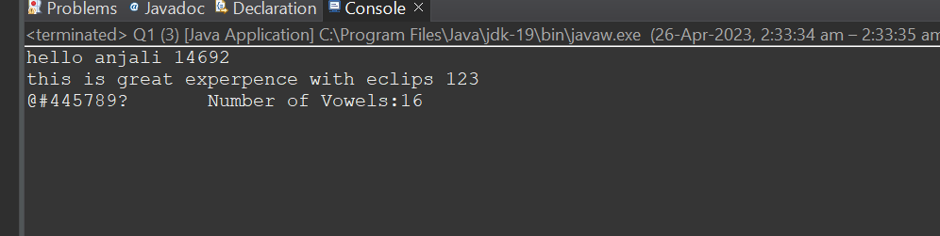

Q 2 wap to copy content of one file to another.

ANS .

**package IO_LAB;**

**import java.io.FileInputStream;**

**import java.io.FileOutputStream;**

**import java.io.FileReader;**

**import java.io.FileWriter;**

**import java.util.ArrayList;**

**public class Q2**

**{**

**public static void main(String[] args)throws Exception**

**{**

**int i;**

**FileInputStream f1= new FileInputStream("abc.txt");**

**FileOutputStream f2= new FileOutputStream("abc1.txt");**

**byte [] b= new byte[1024];**

**int l;**

**while((l= f1.read(b))>0)**

**{**

**f2.write(b,0,l);**

**}**

**System.out.println("Copy Successfully.");**

**}**

**}**

**OUTPUT :**

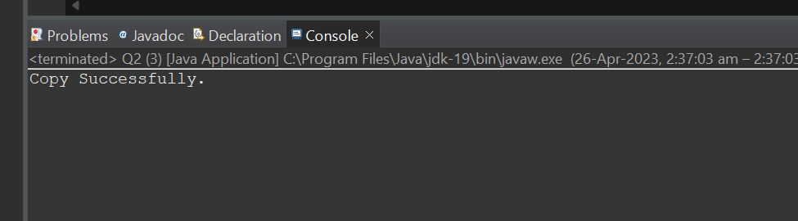

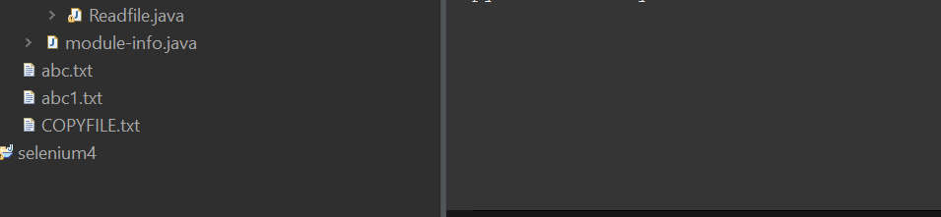

Q 3 wap to read csv file and display in formatted way hint use scaner class split method

ANS .

package IO_LAB;

import java.util.*;

import java.io.File;

import java.io.FileNotFoundException;

public class Q3

{

public static void main(String[] args) throws FileNotFoundException

{

Scanner sc= new Scanner(new File("Anji.csv"));

sc.useDelimiter(",");

while(sc.hasNext())

{

System.***out***.println(sc.next());

}

}

}

**OUTPUT :**

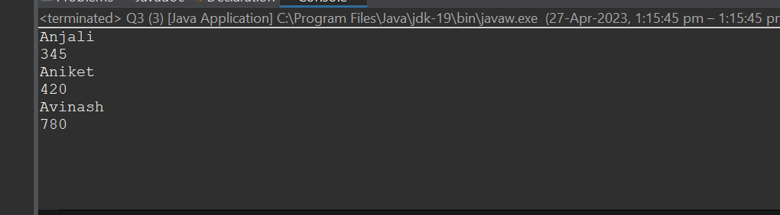

Q4 wap to list file in directory

ANS .

package IO_LAB;

import java.io.*;

public class Q4

{

public static void main(String[] args) throws Exception

{

File diretory= new File("C:\\Users\\Anjali\\Desktop\\Web Tech");

File[] f= diretory.listFiles();

for(File file:f)

{

if(file.isFile())

{

System.***out***.println(file.getName());

}

}

}

}

**OUTPUT :**

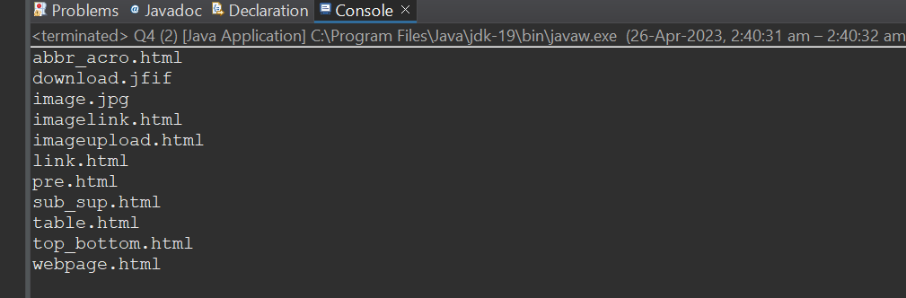

Q 5 Wap to define a class for employee having fields as empno ,name and addresss. Ask employee details from user using scanner in input method . Display details using display method . Write whole object data to file Employee.dat . Read employee data from file and display it on console

ANS .

package IO_LAB;

import java.io.*;

import java.util.Scanner;

public class Employee implements Serializable

{

int empno;

String name;

String addr;

Employee(int e,String n,String a)

{

this.empno= e;

this.name= n;

this.addr= a;

}

Employee()

{

}

void display()

{

System.***out***.println(empno);

System.***out***.println(name);

System.***out***.println(addr);

}

void getrecords() throws Exception

{

Employee e= new Employee(empno,name,addr);

ObjectOutputStream o= new ObjectOutputStream( new FileOutputStream("Employee.dat"));

o.writeObject(e);

o.close();

}

void Show() throws Exception

{

Employee p= new Employee();

ObjectInputStream o= new ObjectInputStream(new FileInputStream("employee.dat"));

p= (Employee) o.readObject();

p.display();

}

public static void main(String[] args)throws Exception

{

Scanner sc= new Scanner(System.***in***);

System.***out***.println("Enter Empno,Emp name & Address");

Employee m= new Employee(sc.nextInt(),sc.next(),sc.next());

m.getrecords();

m.Show();

}

}

**OUTPUT :**

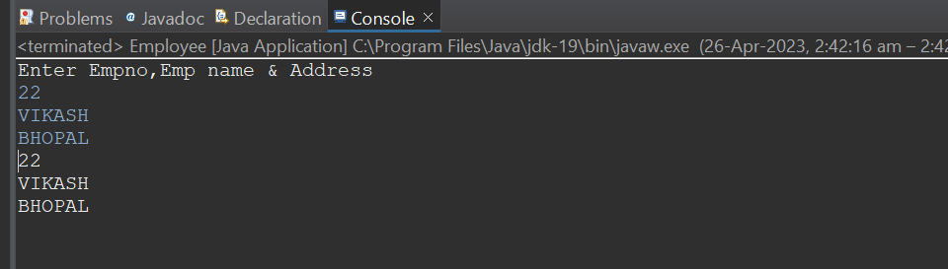

Q 6 create desktop application for library mgt system define class book having fields like bname ,aname ,price and get method and display;

define other methods like

writeToFile()

readfromFile()

searchfromFile()

In main design menu driven application

1) store data to file

2) read data fom file

3) search data from file 4) exit

ANS .

package IO_LAB;

import java.io.File;

import java.io.FileInputStream;

import java.io.FileNotFoundException;

import java.io.FileOutputStream;

import java.io.IOException;

import java.io.ObjectInputStream;

import java.io.ObjectOutputStream;

import java.io.OutputStream;

import java.io.Serializable;

import java.util.Scanner;

class appendable extends ObjectOutputStream

{

appendable(OutputStream o)throws Exception

{

super(o);

}

protected void writeStreamHeader() {}

}

public class Book implements Serializable

{

int bid;

String bname;

int price;

File f= new File("Book2.txt");

public Book(int bid, String bname, int price) throws Exception

{

super();

this.bid = bid;

this.bname = bname;

this.price = price;

}

public Book()

{

super();

}

void display()

{

System.***out***.println("Book id:"+bid);

System.***out***.println("Book Name:"+bname);

System.***out***.println("Book Price:"+price);

}

void write() throws Exception

{

Book p= new Book(bid,bname,price);

if(f.length()==0)

{

ObjectOutputStream o= new ObjectOutputStream(new FileOutputStream(f,true));

o.writeObject(p);

}

else

{

appendable r= new appendable(new FileOutputStream(f,true));r.writeObject(p);

}

}

void read() throws Exception

{

Book b= new Book();

ObjectInputStream q= new ObjectInputStream(new FileInputStream(f));

do

{

b=(Book) q.readObject();

b.display();

}while(b!=null);

}

void search(String n) throws Exception

{

Book b= new Book();

ObjectInputStream o= new ObjectInputStream(new FileInputStream(f));

do

{

b= (Book) o.readObject();

if(n.equals(b.bname))

{

b.display();

}

}while(b!=null);

}

public static void main(String[] args) {

Scanner sc= new Scanner(System.***in***);

int i=1;

Book b1= new Book();

do

{

System.***out***.println("1.Add");

System.***out***.println("2.display");

System.***out***.println("3.Search");

System.***out***.println("4.Exit");

System.***out***.println("Enter your Choice:");

int n= sc.nextInt();

try

{

switch(n)

{

case 1:

System.***out***.println("Enter Book id:");

int id= sc.nextInt();

System.***out***.println("Enter Book Name:");

String name= sc.next();

System.***out***.println("Enter Book Price:");

int p= sc.nextInt();

Book b2= new Book(id, name, p);

b2.write();

break;

case 2:

b1.read();

break;

case 3:

System.***out***.println("Enter Book name to Search:");

String s= sc.next();

b1.search(s);

break;

case 4:

System.***out***.println("Program teminated.");

i=0;

break;

default:

System.***out***.println("Enter valid input");

}

}

catch(Exception e)

{

}

}while(i!=0);

}

}

**OUTPUT :**

